There are errors in your data file; according to Truth sheet, case 1 is abnormal and has one lesion:

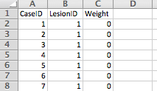

Yet this case appears multiple times in the TP sheet in modality 1:

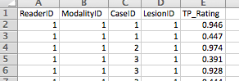

The same lesion cannot be detected more than once in the same modality